

Introduction to Problem Solving and Programming

Project File

By

Mr. :Raushan Kumar
Reg. No: 25BSA10163

Submitted to
Vityarthi

S.No. | Program | Page No.
 | Introduction | 3
2 | Problem Statement | 4
3. | Functional Requirements | 5
4. | Non- Functional Requirements | 6
5. | System Architecture | 7
6. | Design Diagrams | 8 - 11
7. | Implementation Details | 12
8. | Screenshots /Results | 12 - 15
9. | Testing Approach | 16
10. | Challenges Faced | 17
11. | Learning & Key Takeaways | 18
12. | Future Enchancements | 19
13. | References | 19

1.INTRODUCTION

Hostels play a major role in providing a clean and healthy living environment for students. Maintaining hygiene in food, water, cleanliness, and waste management is important for safety and comfort.

This project, Hostel Hygiene Report System, is a simple Python-based application that allows students to submit hygiene-related feedback directly. The system collects ratings, complaints, and suggestions under different categories and generates a final report.

In this project user give rating (good/average/poor) and feedback for :

1.Water Quality
2.Food Quality
3.Cleanliness
4.Mess Hygiene
5.Waste Management

With their name , registration no. , hostel name and room no.

2. Problem Statement

In many hostels, hygiene-related complaints are not recorded properly, leading to delayed responses. Students often struggle to report issues like unclean rooms, poor food quality, or water problems.

There is a need for a simple, interactive system that allows students to submit details quickly and helps authorities maintain cleanliness efficiently.

This project aims to build an easy solution for reporting and storing hostel hygiene feedback.

Categorize reports under important hygiene areas.
Generate a final structured report.
Support both boys’ and girls’ hostels.
Improve communication between students and hostel management.

3. Functional Requirements

These are features this project provide:
1.User Input Module
- Enter student name, registration number, gender, and hostel block.
2.Hostel Block Selection
- Show different blocks based on gender.
- Allow students to choose their room number and block.
3.Category-Based Reporting
  - Water Quality
  - Food Quality
  - Cleanliness
  - Kitchen Hygiene
  - Waste Management
  - Complaints / Feedback
4.Rating System
- Good / Average / Poor
5.Feedback Collection
- Students can write detailed issues.
6.Generate Final Hygiene Report
- Display all recorded feedback in a structured format.
7.Exit Option
- User can finish reporting anytime.

4. Non-Functional Requirements

- Usability
- Easy to use, simple text-based interface.

2.Reliability
- Should run without errors for any valid input.

3.Performance
- Generates reports instantly.

4.Portability
- Works on Windows, Linux, and mobile environments supporting Python.

5.Maintainability
- Code is simple and modular for future upgrades.

5. System Architecture

Student Input

Enter Feedback
Enter Rating
DISPLAY
Gender check

Hostel Blocks

Choose Category

Store Report

Generate Final Report
6. Design Diagram

- USE CASE DIAGRAM

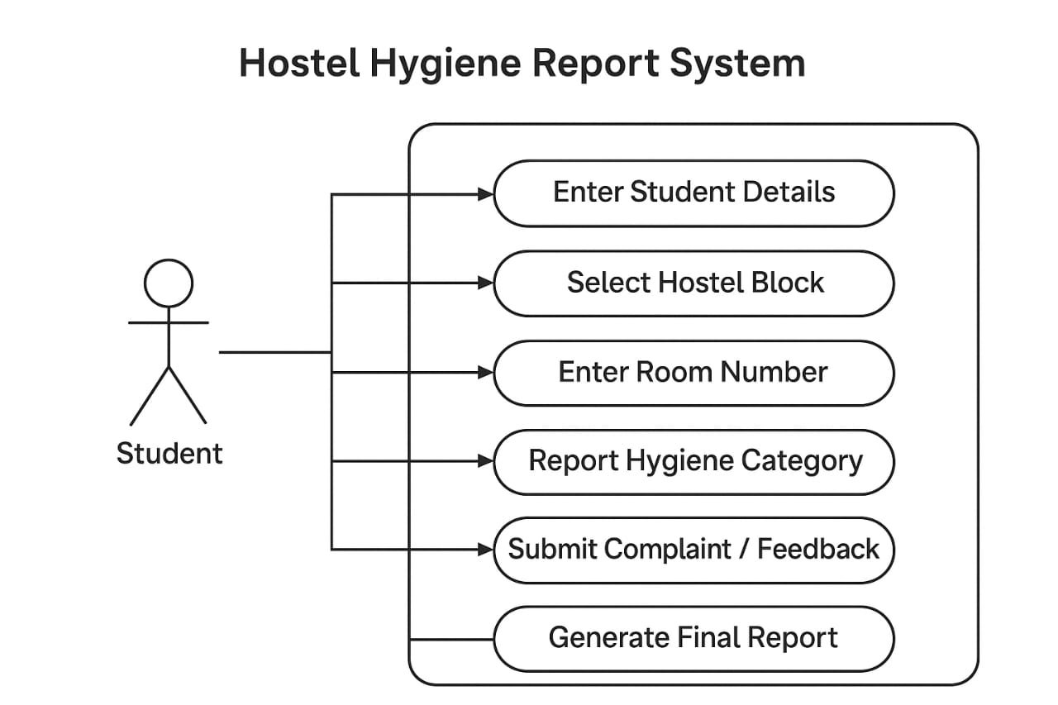

- WORKFLOW DIAGRAM
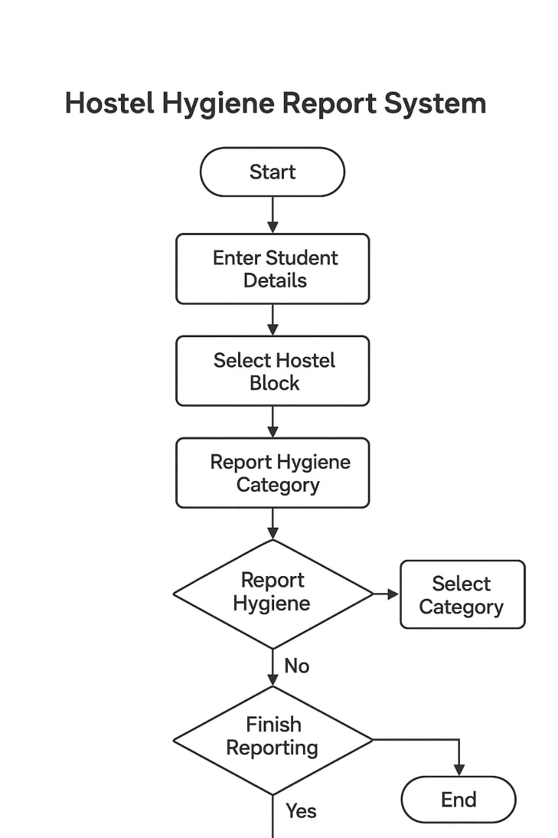

3.SEQUENCE DIAGRAM

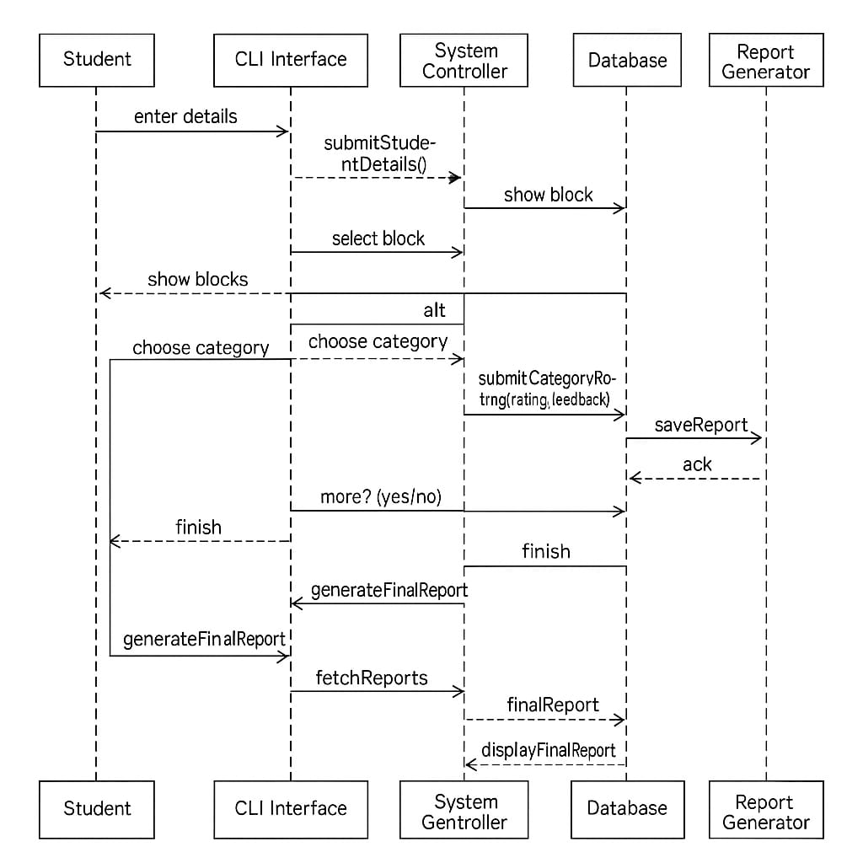

4.CLASS / COMPONENT DIAGRAM

7.Implementation Details

- Programming Language: Python 3
- Concepts Used:
- Input/output functions
- Conditional statements
- Lists and dictionaries
- While loops
- String formatting
- No external libraries required.

8. Screenshots/Results
PROCESS / CODING

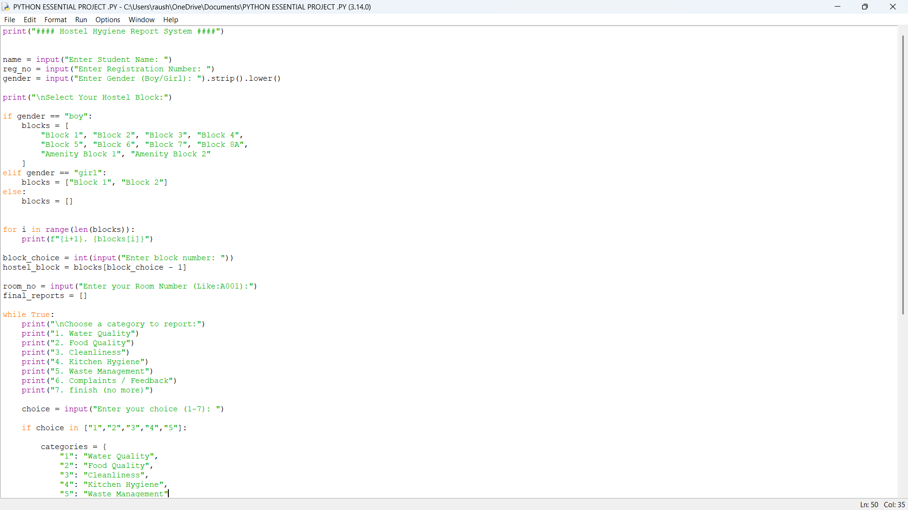
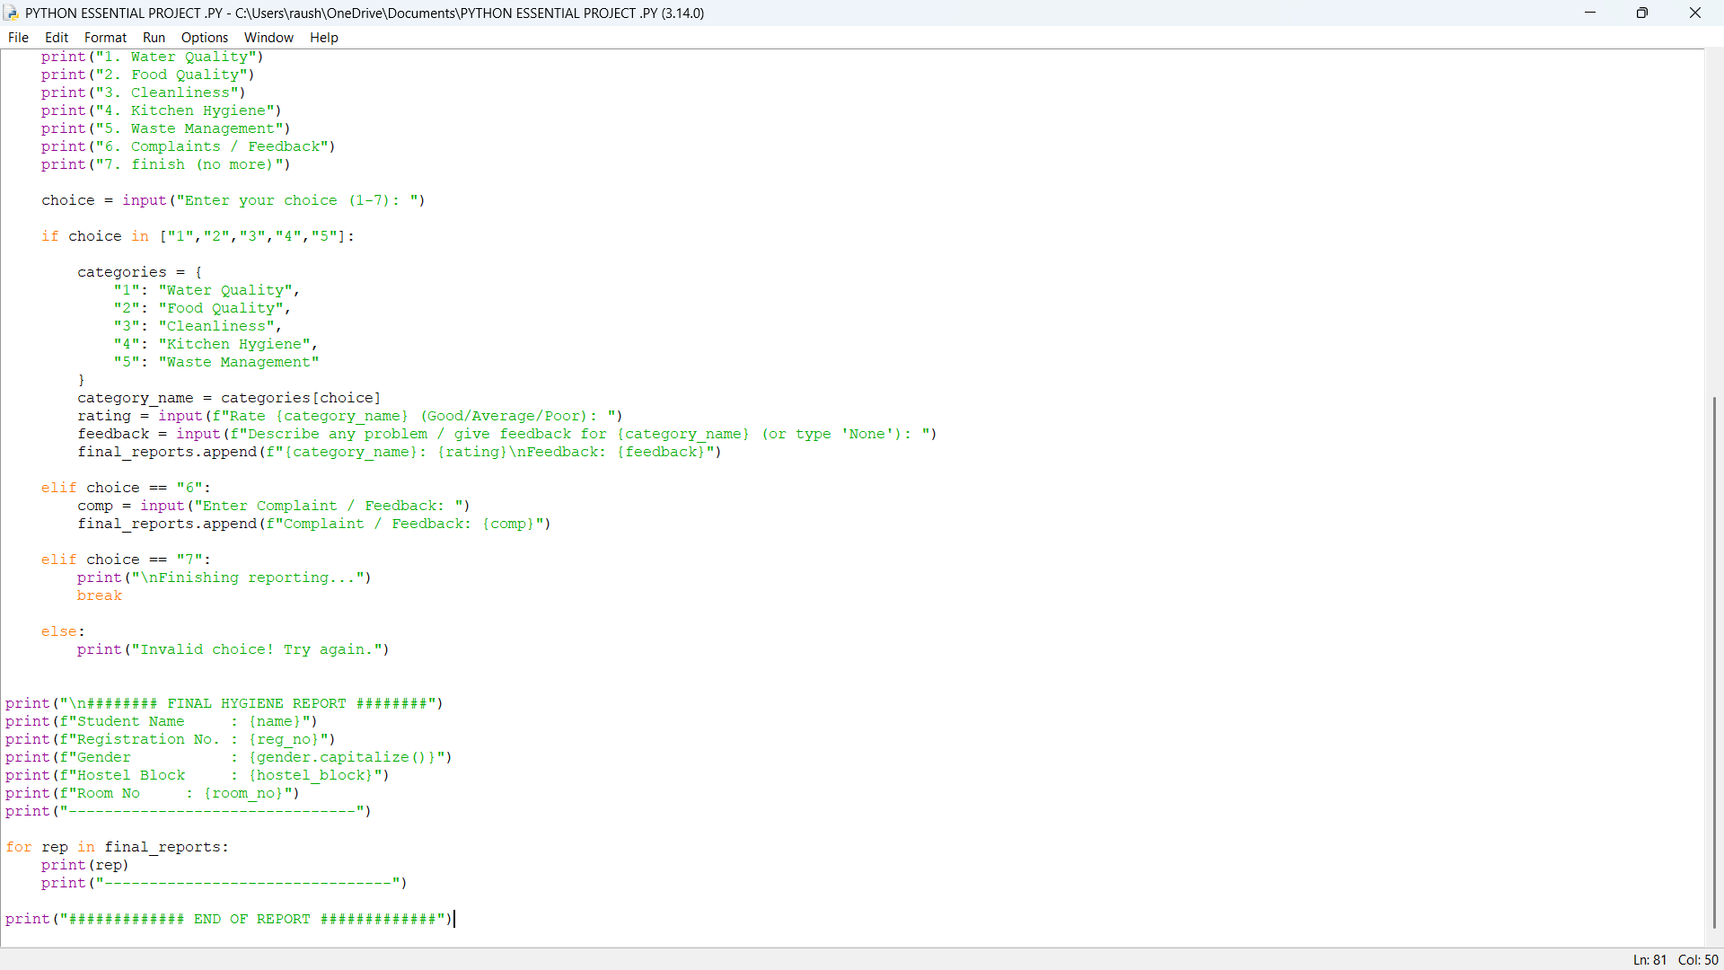

UNDER PROCESS………….

OUTPUT 1
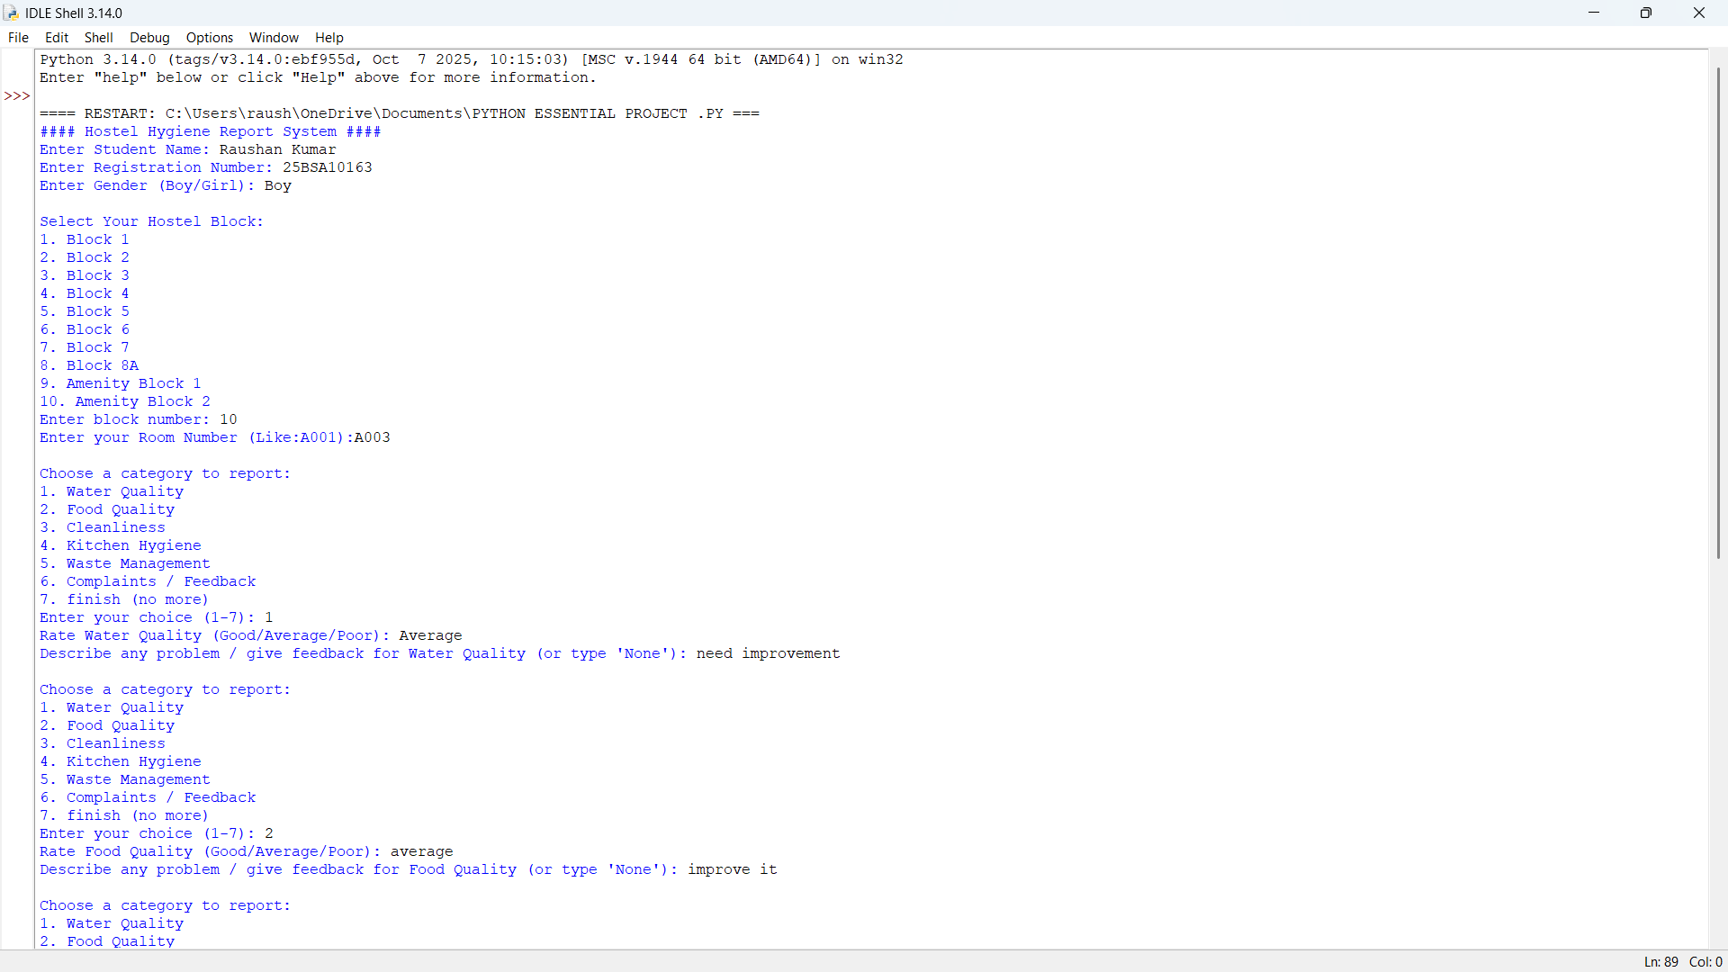

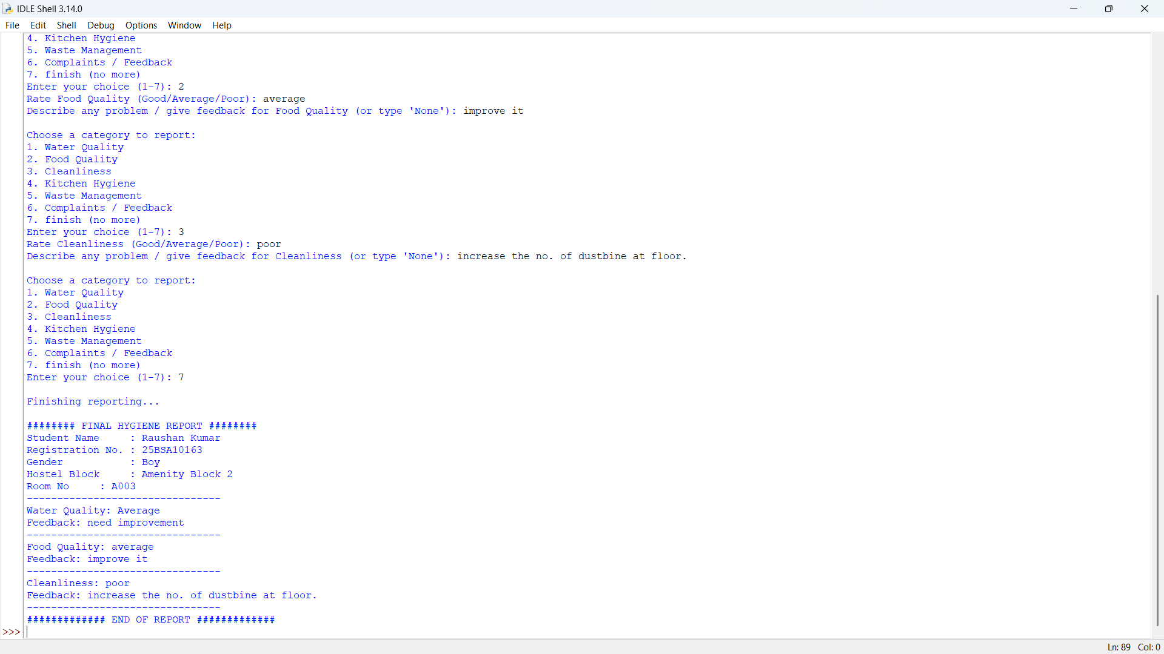
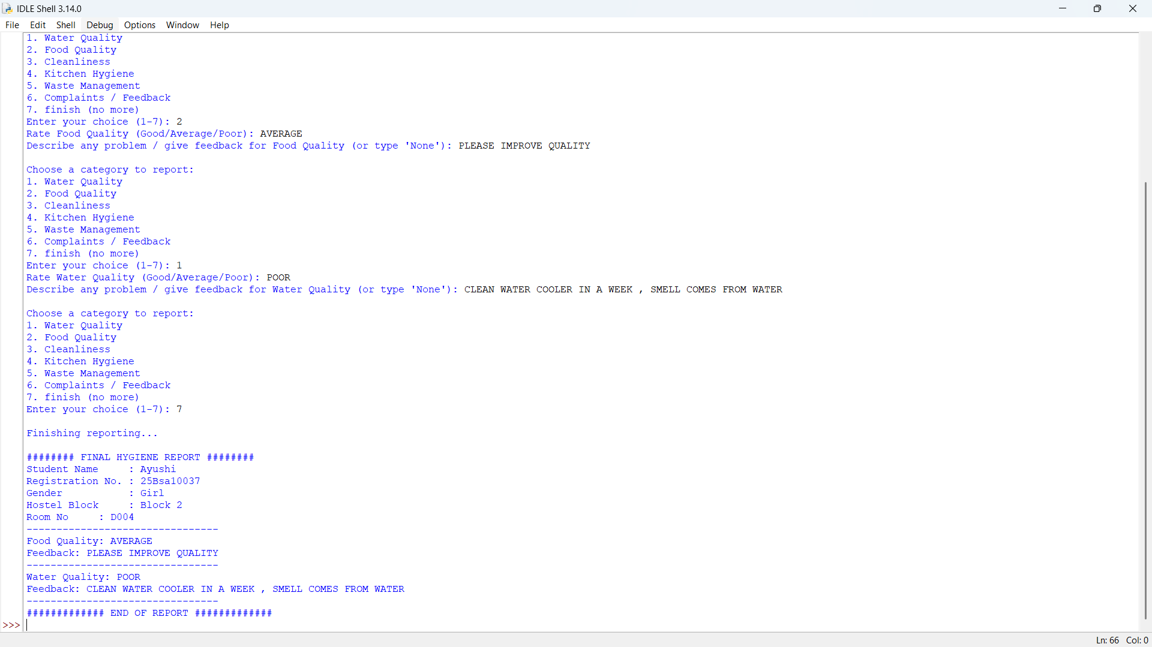
OUTPUT 2

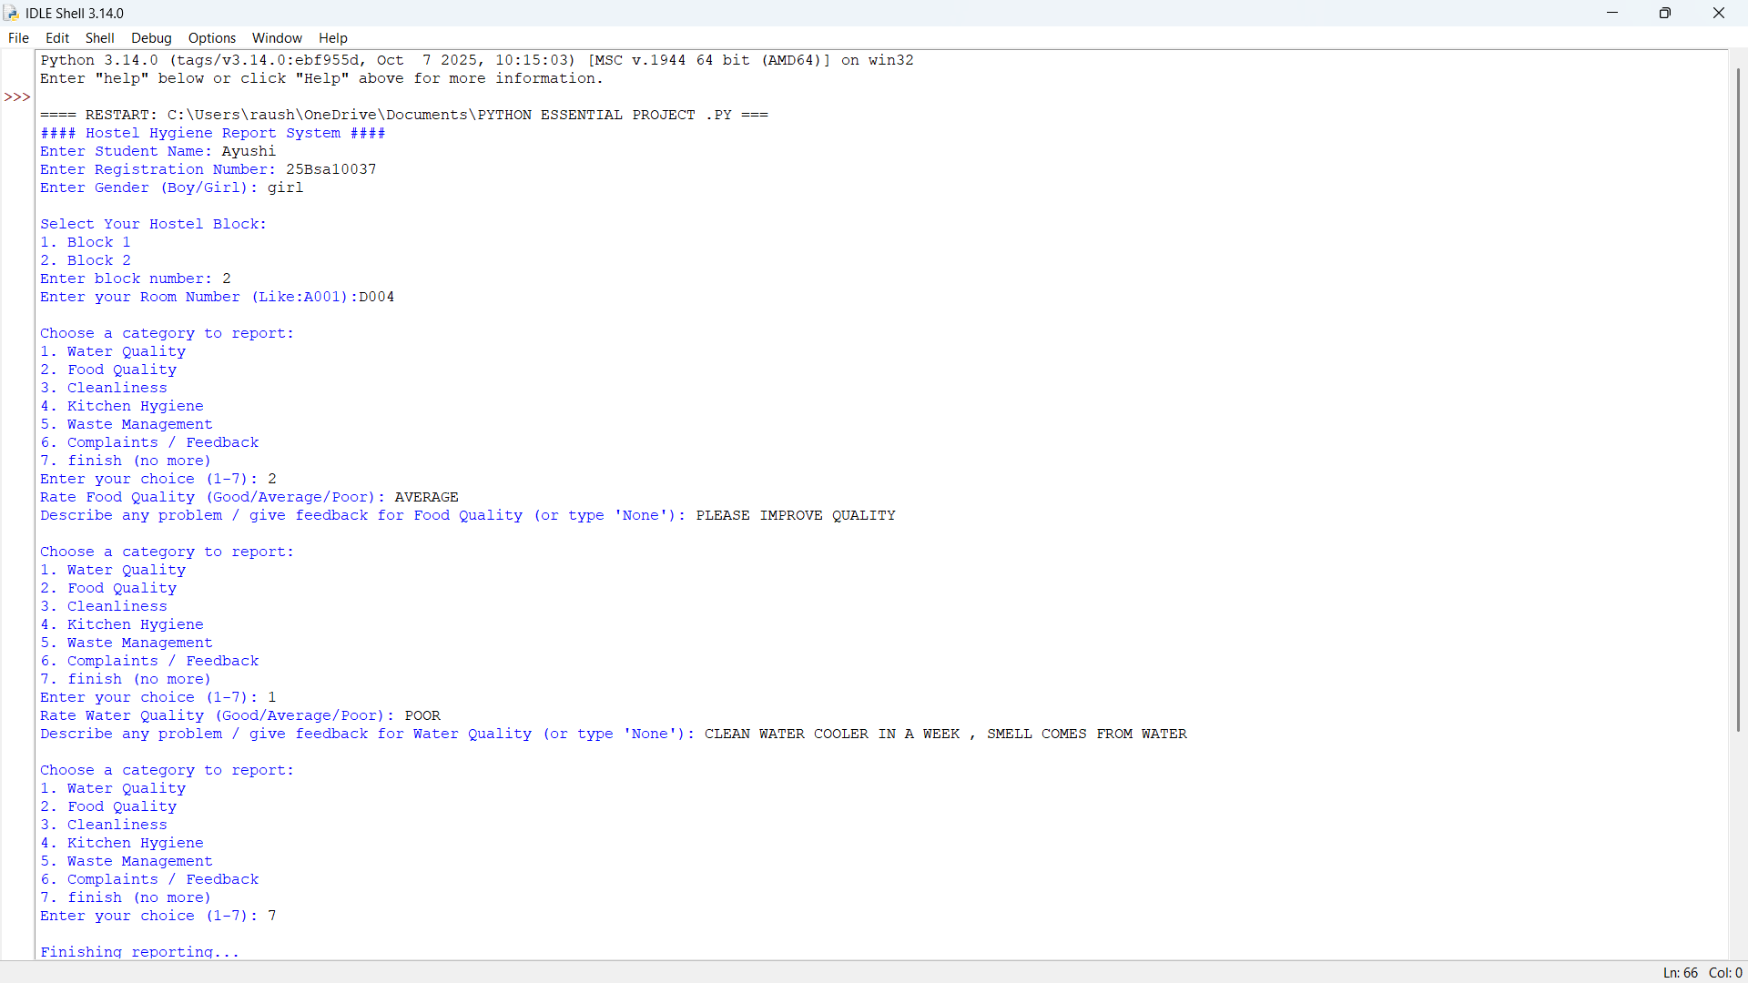

9.TESTING APPROACH

TEST CASE | INPUTS | EXPECTED OUTPUTS
1 | GENDER=BOY | DISPLAYS 10 BLOCKS
2 | GENDER =GIRL | DISPLAYS 2 BLOCKS
3 | CATEGORY(WATER) | ASKING FOR RATING + FEEDBACK
4 | FINISH(7) | LOOP ENDS AND REPORT DIPLAYS
5 | WRONG INPUT | SHOWS “INVALID CHOICE”.

TESTING METHOD :
# MANUAL TESTING
#BOUNDARY VALUE TESTING
#INVALID INPUT TESTING

10. CHALLENGES FACED

During the development of the hostel hygine report project , I faced many challenges:

1). Data entry error.
When user use first letter small in boy instead of Boy in gender choice it shows error, after many try we found a function .srip() .lower() , now its works perfect.

2). During using loop
Using “while true” loop was slightly challenging , many times code not run shows error, actually I wanted students to be able to report more than one issue at a time .For this I used a while true loop. The challenge was to make sure the loop continued when needed and stopped only when user selected the “finish” option. Controlling the loop properly was a bit tricky.

3). Showing Correct Hostel Block Based on Gender
Boys and girls have different hostel blocks. Making the program show only the blocks that apply to the selected gender required careful logic. A small mistake could show the wrong block list or cause confusion.

4).Managing Many Categories
There were many categories like Water Quality, Food Quality, Cleanliness, Kitchen Hygiene, and Waste Management. Storing the ratings and feedback for each category in a neat and clear way was a challenge at first. I used a list and dictionary to keep things organized.

5). Testing the Program with different Inputs
I had to test the program with many types of inputs—correct ones, wrong ones, empty ones, and random ones. Many small mistakes were found during testing. Fixing these issues and making sure the program works in all situations required time and patience.

11.Learning & Key Takeaways

Working on the Hostel Hygiene Report System helped me learn many useful things about Python and project development:

- Better Understanding of Python Basics

- Using loops Effectively ( I understood how “while True” loops work and how they help in taking repeated inputs until the user finishes.

- Handling User Input Carefully (I learned how to manage different types of inputs like texts, nos. , gender, categories choices….

- Formatting output Properly (I learned how to format the final hygine report nearly so it looks clear and professional.

- Improving Logical Thinkling (Breaking the big task into smaller steps improved my logical thinking and made it easier to design the entire system.

- Gaining confidence in CODING

COMPLITING THIS PROJECT HELPED ME FEEL MORE CONFIDENT IN WRITING PYTHON PROGRAMS AND DEVELOPING SMALL APPLICATIONS.

12. Future Enhancements

1). Save REPORTS to a file.
2.) Admin login Feature.
3.) Add more categories like (bathroom cleaniness, laundary quality, electricity)
4.) Create Graphical User Interface .
5) Store Data in Interface
6) QR code Reporting System (scan QR and directly open reporting system)
7)Auto Notification system (Hostel authorities can receive automatic emails or message whenever a new complaint is submitted)

13.References

1). From vityarthi tutorial
2). Class notes.
3). You tube videos.
4) . Introduction to problem solving by python Book.

